23CSE111
OBJECT ORIENTED PROGRAMMING
LAB REPORT



Department of Computer Science Engineering
Amrita School of Computing
Amrita Vishwa Vidyapeetham,
Amaravati Campus

Verified by: NAME:T. SAI RAHUL NAVANEETH
ROLL NO:AV.SC.U4CSE24334

INDEX
S.NO | EXPERIMENT | SIGNATURE
1. | Installing java in our device.
2. | Program for entering student details.
3. | Program to calculate the simple intrest
4. | To find Fibonacci series upto some number.
5. | To find temperature in Celsius.
6. | To find factorial of a given number.
7. | Program to convert from Celsius to fahrenhiet
8. | Program to calculate the area of a triangle using heron’s formula.
9. | To create java program with following instructions  1.Create a class with name car  2. Create four attributes named car_color ,Car_brand,fuel_type,mileage  3. Create three methods named start(), stop(). Service()  4. Create three objects named car1,car2 and car3
10. | To create a class bankAccount with methods deposit() and withdrawl
11. | Write a java program with class named “book”. the class should contain various attributes such as title, author, year of publication. it should also contain a constructor with parameters which initializes title, author, year of publication and create a method which displays the details of 2 books.
12. | Write a java program with class named “myclass” with a static variable count of int type. intialize it to zero and a constant variable “pi” of type double initialized to “3.14” as attributes of that class. now define a constructor for “myclass”, that increments the count variable each time an object of “myclass” is created. finally, print the final values of ‘count’ and ‘pi’ variables and create 3 objects.
13. | create a calculator using the operations add, subtarct, multiplication and division using multilevel inheritance and display the desired output.
14. | A vehicle rental company wants to devlop a system that maintains information about different types of vehicles available for rent. The company rents out cars , bikes and trucks and they need a program to store details about each vehicle, such as brand and speed.  *Cars should have an additional property such as number_of_doors .  *Bikes should have a property indicating whether they have gears or not.  *Truck should have a property of their capacity(in tons).  *Every class should have a constructor.

WEEK-1:
Aim: How to install jdk and first program on
printing student details.

Step-1: Download JDK-21 from oracle website
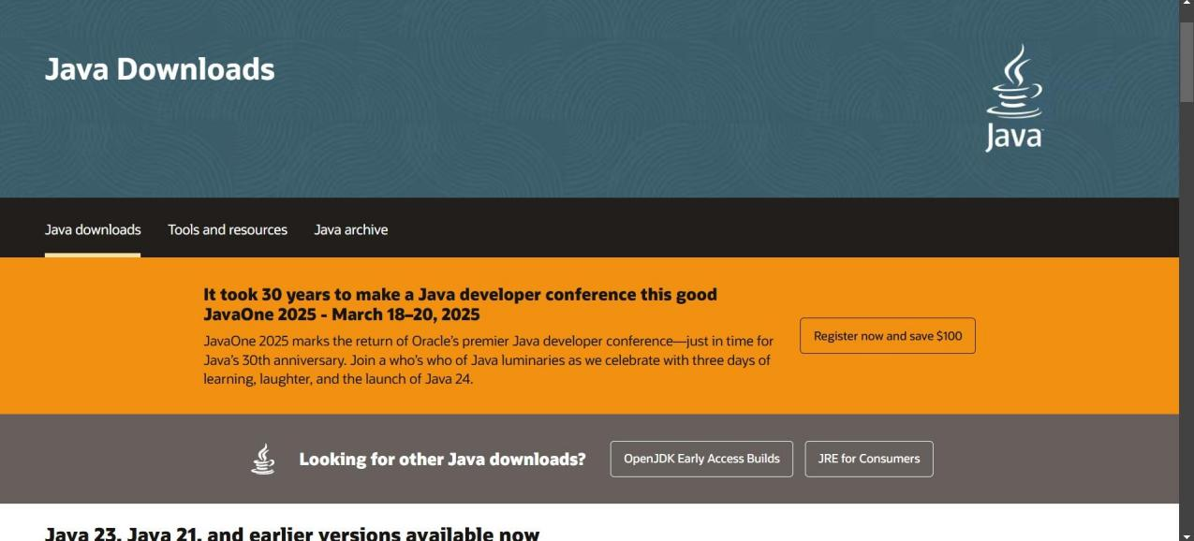

Step-2:Install the JDK-21 with accepting terms and
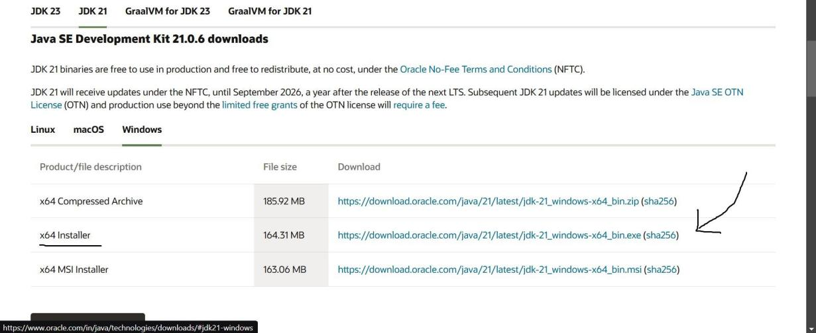
conditions according to the respective windows.

Step-3:Setting up environmental variables.
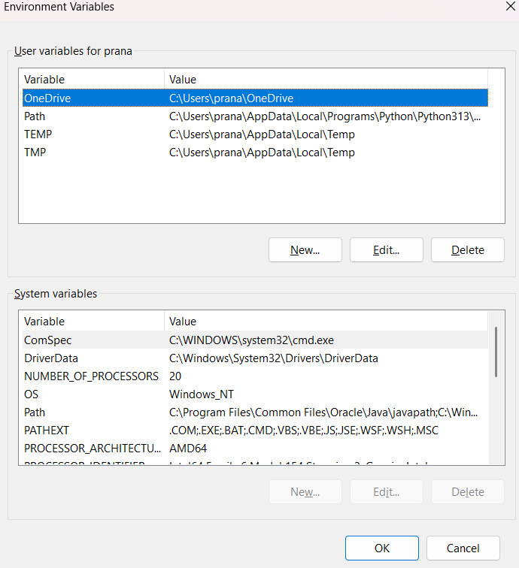

*Windows c -> C-drive -> program files ->Java -
>JDK-21->select bin

*Select and open environmental variable in search
bar-> either select system variables or user
variables-> select path-> click edit->New-> paste
the bin-> finish the setup(apply the changes).

~for verifying the installed version

Open cmd-> type java --version

~command propt
Javac filename.java ->compiling.

Java filename.java ->display

PROGRAM-1:
Aim: Write a program in java for displaying
student details.

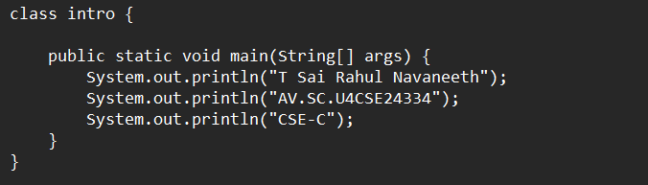

Output:

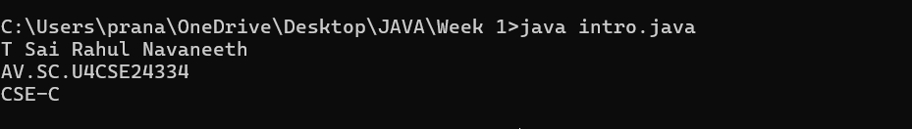
Code \ | Error | Rectification
System.out.println  ("Class: CSE-C") | Semi colon(;) is  missing at the  end. | Add a semi colon(;) at the  end.  System.out.println("Class:  CSE-C");

WEEK-2:
PROGRAM-1:
Aim: Write a java program for SI

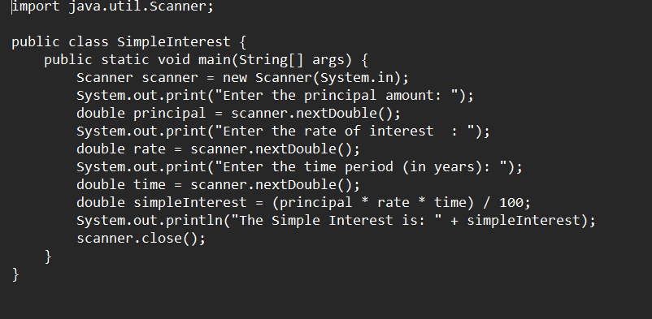
Output:
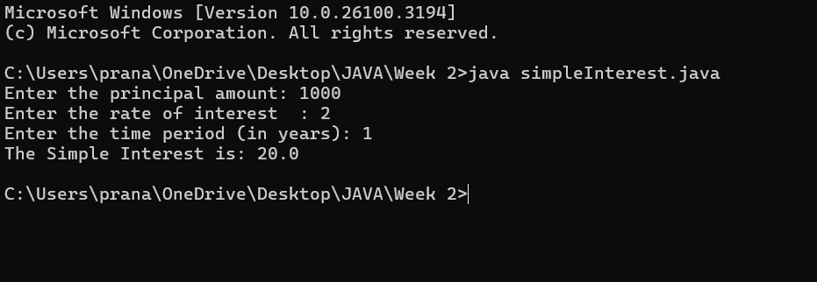

ERROR TABLE:

Code Error | Code rectification
1.Giving space between next and Double.  2.Not using the closing semi colon. | 1.Should not give space between next and Double.  2.We must put semi colon after each line when required.

PROGRAM-2:
Aim: Write a program in java for area of
rectangle.

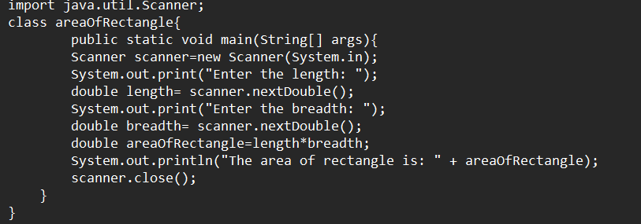

Output:

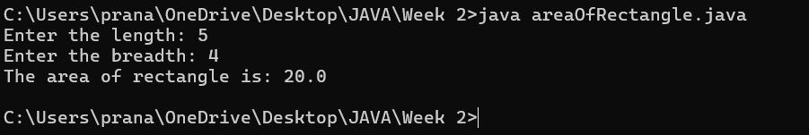
IMPORTANT POINTS:
- Area of a rectangle is area = l*b, where
L = length of a side of the rectangle,
B= breadth of a side of the rectangle.
- Here, we must be sure that all the expressions/conditions inside for the for loop must be given correctly.

ERROR TABLE:

Code Error | Code rectification
1.While using for iteration, not giving the conditions correctly.  2.Declaring the data type. | 1.We should give iterative statements correctly.  2.We should give the data type.

PROGRAM-3:
Aim: Write a program in java for area of triangle using heron’s formula.

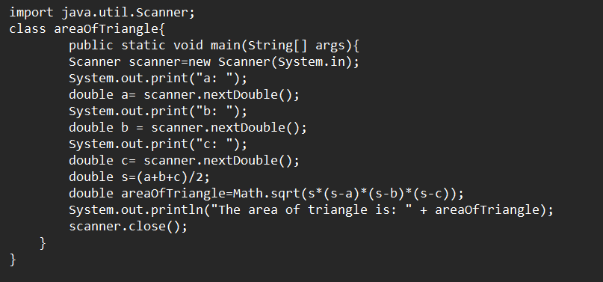

Output:

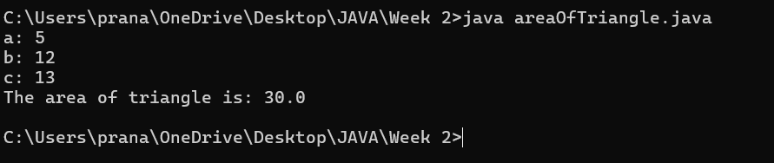
IMPORTANT POINTS:
- Here, we’re finding the area of a triangle using heron’s formula.
- Heron’s formula for finding a triangle is:
S = (a +b +c)/2
Where S is the semi-perimeter of the triangle.
Now the area formula is:
Area = sqrt(s*(s-a)*(s-b)*(s-c)).

ERROR TABLE:

Code Error | Code rectification
1.While printing the variable not giving + sign.  2.Declaring the data type. | 1.We should give correct indentation.  2.We should give the data type.

PROGRAM-4(a):
Aim: Write a program in java for converting temperature from Celsius to Fahrenheit.

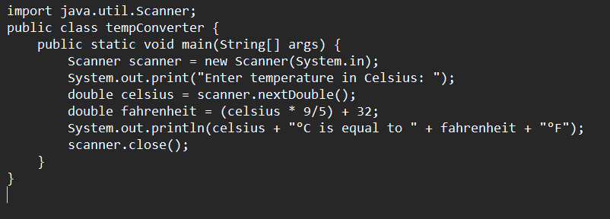

OUTPUT:

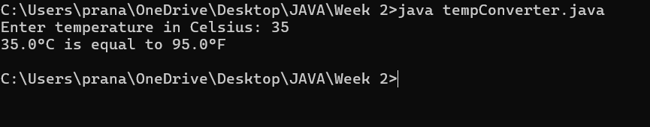

PROGRAM-4(b):
Aim: Write a program in java for converting temperature from Fahrenheit to Celsius.

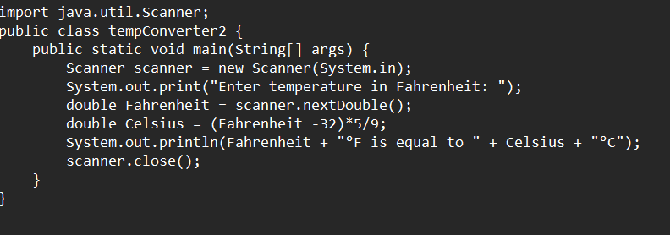

Output:

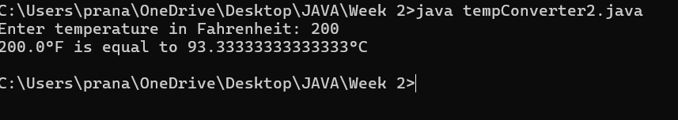

ERROR TABLE:

Code Error | Code rectification
1.While printing the variable not giving + sign.  2.Not closing the scanner. | 1.We should give correct indentation.  2.Closing the scanner is must.

PROGRAM-5:

Aim: Write a program in java for factorial of a number.

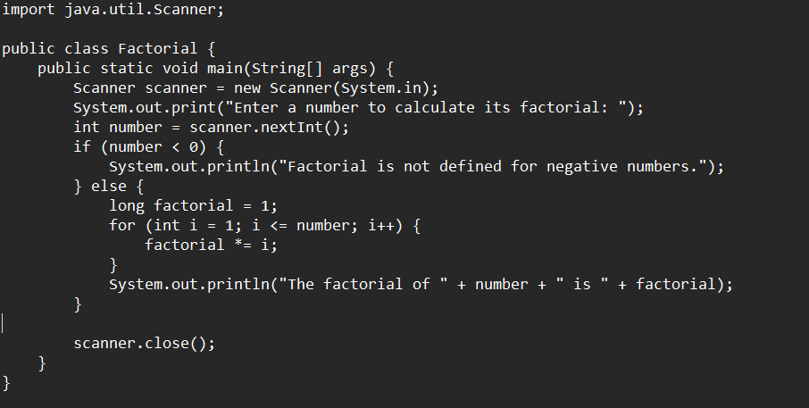
OUTPUT:

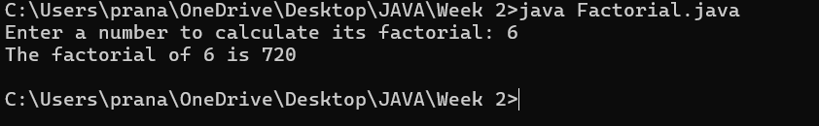

ERROR TABLE:

Code Error | Code rectification
1.While using for iteration, not giving the conditions correctly. | 1.We should give iterative statements correctly.

PROGRAM-6:
Aim: Write a program in java for Fibonacci series.

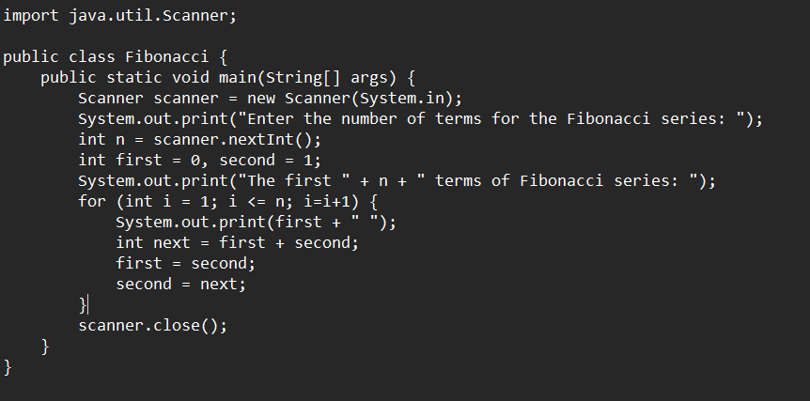
IMPORTANT POINTS:
- In the Fibonacci sequence, the sum value is given to the second variable, and the value of the second variable is given to the first variable.
- This process is repeated a certain number of times until the conditions are met.

OUTPUT: 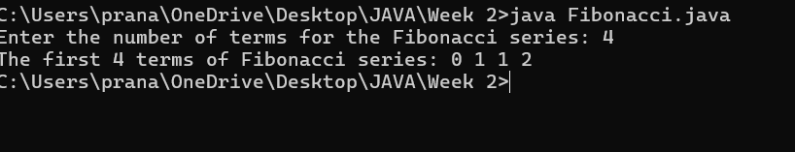
ERROR TABLE:

Code Error | Code rectification
1.Giving space between next and Double.  2.Not putting flower brackets in the end. | 1.Should not give space between next and Double.  2.We must put giving flower brackets in the end.

WEEK -3:
PROGRAM-1:
AIM: To create java program with following instructions:
1.Create a class with name Car.
2.Create four attributes named car color, car brand, fuel type, mileage
3.Create these methods named start (), stop (), service ()
4.Create the objects named car, car1, car2

CODE:

public class Car {
private String car_color;
private String car_brand;
private String fuel_type;
private String mileage;

public void start() {
System.out.println("car is started");
}

public void stop() {
System.out.println("car is stopped");
}

public void service() {
System.out.println("car is for service");
}

public static void main(String args[]) {
Car car = new Car();
car.car_color = "white";
car.car_brand = "audi";
car.fuel_type = "petrol";
car.mileage = "20";
car.start();
System.out.println("car_color: " + car.car_color + " car_brand: " + car.car_brand + " fuel_type: " + car.fuel_type + " mileage: " + car.mileage);
Car car1 = new Car();
. car1.car_color = "white";
car1.car_brand = "audi";
car1.fuel_type = "petrol";
car1.mileage = "20";
car1.stop();
System.out.println("car_color: " + car1.car_color + " car_brand: " + car1.car_brand + " fuel_type: " + car1.fuel_type + " mileage: " + car1.mileage);
Car car2 = new Car();
car2.car_color = "white";
car2.car_brand = "audi";
car2.fuel_type = "petrol";
car2.mileage = "20";
car2.service();
System.out.println("car_color: " + car2.car_color + " car_brand: " + car2.car_brand + " fuel_type: " + car2.fuel_type + " mileage: " + car2.mileage);
}
}

OUTPUT:

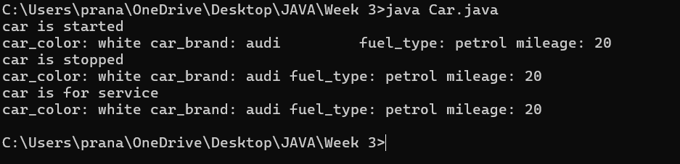
Error table:
S.no | error | Rectification
1 | Missing ‘;‘ | ‘;‘ added
2 | Mispelled Variable call | Rectified with  Correct variable name
3 | Uppercase and lowercase | rectified
IMPORTANT POINTS:
- Before calling the function we should write the method properly.
- Here, the “public void start( )” indicates that we are writing a method to call the function.
- When we call a certain method, the process inside it will be printed as an output of the code.
- Here the details inside the function are called objects, we can give any objects
Class diagram:
car
-----------------------
-car_color:string
-car_brand:string
-fuel_type:string
-milage:double
----------------------
+start():void
+stop():void
+service():void

PROGRAM-2:
Aim: To create a class BankAccount with methods deposit() and withdraw() . create two subclasses savingsaccount and checkingaccount override the withdraw () method in each subclass to impose different withdrawal limits and fees

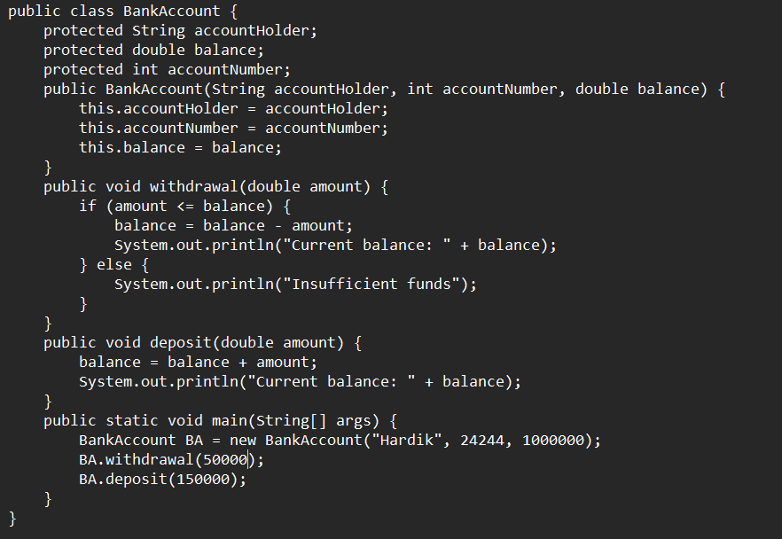

OUTPUT:

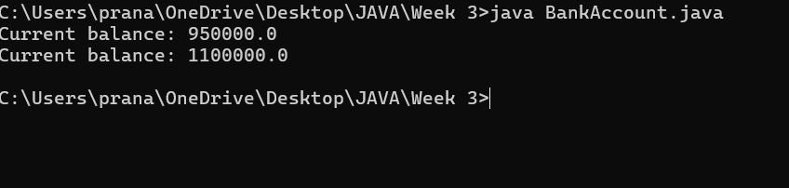

IMPORTANT POINTS:
- The condition inside the if statement must be correct.
- It explains that if the withdrawal money is less than the money in the bank account, then we can withdraw the amount.

Error table:

S.no | Error name | Error name | Rectification
1 | Name Error | Undefined name | Correct variable  Name replaced
2 | Syntax Error | Missing Parenthesis | Parenthesis Added
3 | Logical Error | Incorrect Condition | Condition Rectified

Class diagram:
BankAccount
----------------------------------------------------------
-balance: double
----------------------------------------------------------
+BankAccount(intialBalance: double)
+deposit(amount: double):void
+withdraw(amount: double):void

WEEK-4:
PROGRAM-1:
Aim: Write a java program with class named book .The class should contain various attributes such as Title ,Author and Year of Publication .It should also contain a constructor with parameter which initializes Title ,Author and Year of publication .Create a method which displays the details of the book .Display the details of two books.

CODE:

class book{
public String title;
public String author;
public String year_of_publication;

public void book(){
this.title=title;
this.author=author;
this.year_of_publication=year_of_publication;
}
public static void main(String[] args){
book book1=new book();
book book2=new book();
book1.book();
book1.title="Sherlock Holmes ";
book1.author="Arthur Conan Doyle";
book1.year_of_publication="1887";
book2.book();
book2.title="Harry Potter";
book2.author="J.K. Rowling";
book2.year_of_publication="1997";
System.out.println("Book-1");
System.out.println("Title :" +book1.title);
System.out.println("Author :" +book1.author);
System.out.println("Year of publication :" +book1.year_of_publication);
System.out.println("Book-2");
System.out.println("Title :" +book2.title);
System.out.println("Author :" +book2.author);
System.out.println("Year of publication :" +book2.year_of_publication);
}
}

OUTPUT:

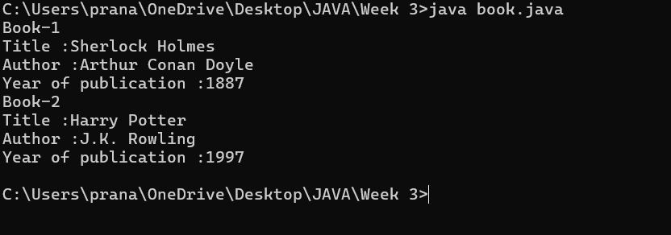
Class Diagram:

Book
- Title: String
- Author: String
- Year of publication: int

+ Book(title: String,
Author: String;
Year of publication: int
+ displayDetails( ): void

IMPORTANT POINTS:
- While defining two classes for a code, we must be sure that we save both the classes in separate files.
- While defining a method we should also define a function to call that method.

Error Table:

S.No | Error | Rectification
1. | Missing “;” after calling method. | Added “;”

PROGRAM-2:

Aim: Create a java program with class named myclass with a static variable count of int type initialized to 0 and a constant variable “Pi” of type double initialized to 3.14 has attributes of that class .Now define a constructor for “myclass” that incerements the count variable each time an object of myclass is created finally print final values count and Pi variables .Create three objects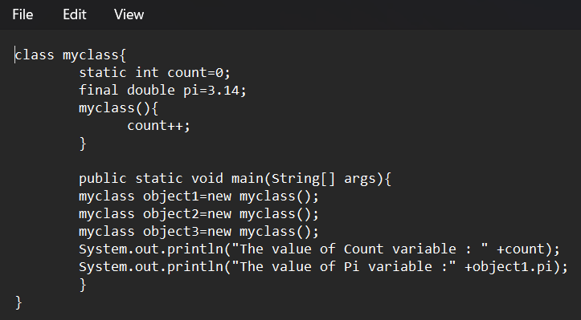

OUTPUT:

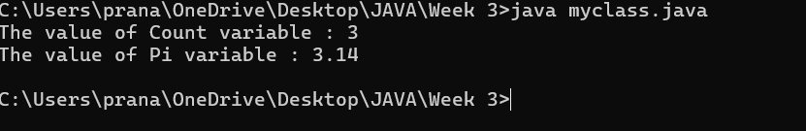

Class Diagram:

Myclass
- Count: int
- Pi: double

+ myclass( )
+ main(args: String[]): void

IMPORTANT POINTS:
- We must declare the initial value of the variable before declaring the final one.
- Here the main objective is to increase the count according to the number of objects we make, i.e the count increases when the no.of objects are increasing.

Error Table:
S.No | Error | Rectification
1. | Not typing “}“ at the end of the code. | Added “}”.

WEEK -5
1)AIM: Create a calculator using the operations including addition, subtraction, multiplication and division using Multilevel Inheritance and display the desired output.
CLASS DIAGRAM:
BasicCalculator
+add(a:double,b:double):double
+subtract(a:double,b:double):double

IntermediateCalculator
+multiply(a:double,b:double):double

ScientificCalculator
+divide(a:double,b:double):double

Program:
class addition
{
public int add(int a, int b)
{
int addition = a+b;
return addition;
}
}
class subtraction extends addition
{
public int sub(int a, int b)
{
int subtraction = a-b;
return subtraction;
}
}
class multiplication extends subtraction
{
public int mult(int a, int b)
{
int multiplication = a*b;
return multiplication;
}
}
class division extends multiplication
{
public int div(int a,int b)
{
int division = a/b;
return division;
}
}
class calculator
{
public static void main(String args[])
{
division obj = new division();
System.out.println("Addition is:"+ obj.add(10,2));
System.out.println ("Subtraction is:"+obj.sub(8,4));
System.out.println("Multiplication is:"+obj.mult(12,4));
System.out.println("Division is:"+obj.div(8,4));

}
}

Output:
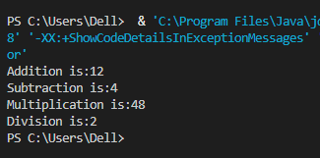

Error:
S.No | Error type | Reason for error
1. | Syntax | Bsec.java:23:error:illegal character:’\u00a0

Important Points:-
Inheritence:
The concept of OOP where a class inherits the properties and behaviours from
Another class (parent class) which promotes code reusability and hieratchical relationships

Multilevel Inheritence:
This is a type of inheritance in which a class inherited from another class, and
That superclass, in turn, inherits from yet another class, creating a chain of
Inheritance

2) AIM: A vehicle rental company wants to develop a system that maintains information about different types of vehicles available for rent. The company rents out cars and bikes and they need a program to store details about each vehicle such as brand and speed
• Cars should have an additional property: number of doors
• Bike should have a property indicating whether they have gears or not
• The system should also include a function to display details about each vehicle and indicate when a vehicle is starting
• Every class should have a constructor
1. Which OOP concept is used in the above program? Explain why it is useful in this scenario.
2. If the company decides to add a new type of vehicle truck, how would you modify the program? Truck should include an additional property capacity(in tons). Create a showTruckDetails() method to display the truck’s capacity. Write a constructor for truck that initializes all properties.
3. Implement the truck class and update the main method to create a truck object, also create an object for car and bike subclassed. Finally display its details.
CLASS DIAGRAM:
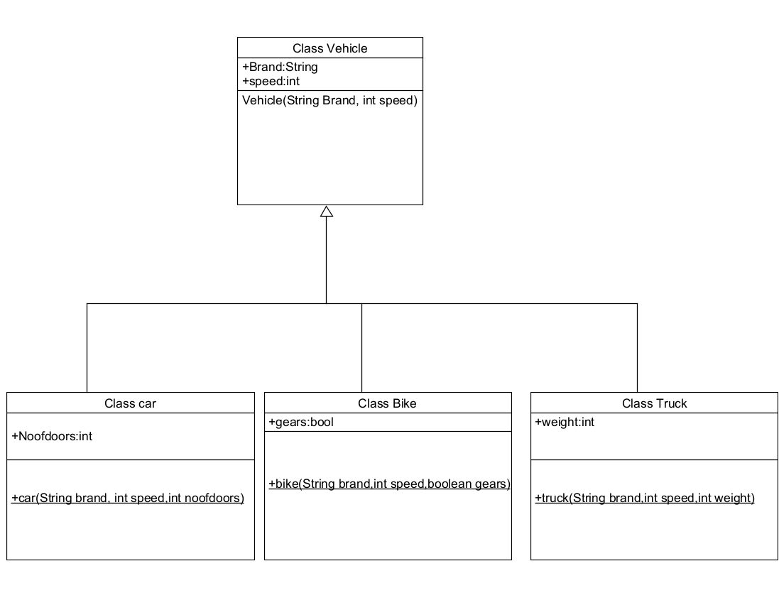

Program:
class Vehicle {
String brand;
int speed;

public Vehicle(String brand, int speed) {
this.brand = brand;
this.speed = speed;
}

public static void main(String[] args) {
Car obj1 = new Car("Ford", 34, 4);
Bike obj2 = new Bike("Hero", 100, true);
Truck obj3 = new Truck("Tata", 60, 40);
}
}

class Car extends Vehicle {
int noOfDoors;

public Car(String brand, int speed, int noOfDoors) {
super(brand, speed);
this.noOfDoors = noOfDoors;
System.out.println("Brand of car is: " + brand);
System.out.println("Speed of car is: " + speed);
System.out.println("No of doors of car: " + noOfDoors);
}
}

class Bike extends Vehicle {
boolean gears;

public Bike(String brand, int speed, boolean gears) {
super(brand, speed);
this.gears = gears;
System.out.println("Brand of bike is: " + brand);
System.out.println("Speed of bike is: " + speed);
System.out.println("Gears of bike: " + gears);
}
}

class Truck extends Vehicle {
int weight;

public Truck(String brand, int speed, int weight) {
super(brand, speed);
this.weight = weight;
System.out.println("Brand name is: " + brand);
System.out.println("Speed of Truck is: " + speed);
System.out.println("Weight of load is: " + weight);
}
}

Output:
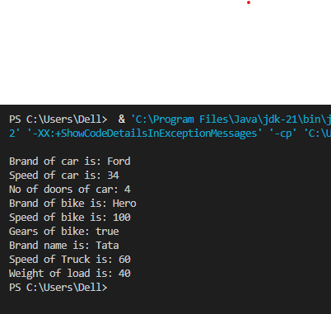
NEGATIVE CASE:
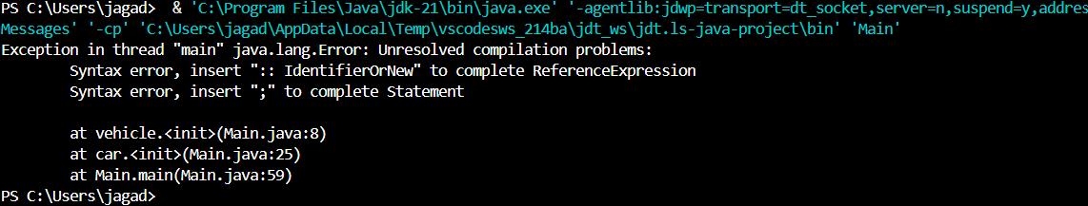

ERROR TABLE:-
S No | Error Type | Cause | Rectification
1 | Syntax Error | Semicolon missing | Added ;

Important Points
Hierarchical Inheritence:
This is a type of inheritance occurs when multiple subclasses inherit from a
Single parent class

ERROR:

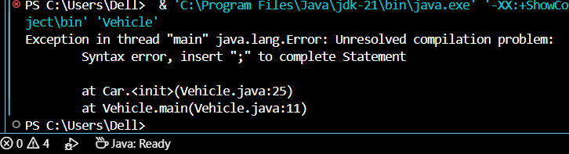
WEEK- 6
1)AIM: Write a java program to create a Vehicle class with a method displayInfo(). Override this method in the Car subclass to provide specific information about a car.
CLASS DIAGRAM:
vehicle
+displayinfo():void

car
Color:String
Speed:int
Model:String
Type:String
Fueltype:String
+displayInfo():void

Program:
class vehicle{
String company;
String model;
String fuel;
int capacity;
void displayInfo(String company,String model,String fuel,int capacity){
System.out.println("The details of vehicle: ");
this.company=company;
this.model=model;
this.fuel=fuel;
this.capacity=capacity;
}
}

class car extends vehicle{

void displayInfo(String company,String model,String fuel,int capacity){
System.out.println("Company: "+company);
System.out.println("Model: "+model);
System.out.println("Fuel: "+fuel);
System.out.println("Capacity: "+capacity);
}
}
class poly1{
public static void main(String[] args){
car car1=new car();
car1.displayInfo("Audi","Model","Diesel",4);
}
}
Output:
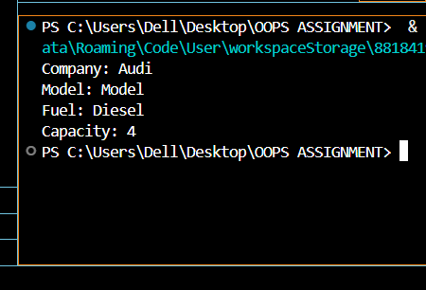
NEGATIVE CASE:

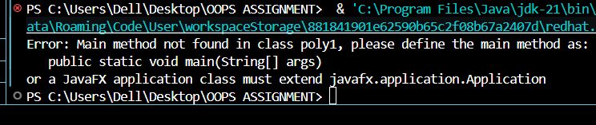

ERRORS :
S.No | Error type | Reason for error | Rectification
1 | Syntax error | [] is missed | [] is added
2 | Logical error | Incorrect logic | Correct logic

2) A college is developing an automated admission system that verifies students eligibility for undergraduate(UG) and postgraduate(PG) programs. Each program has different eligibility criteria based on the student's percentage in their previous qualification.
UG Admissions require a minimum of 60%.
PG Admissions require a minimum of 70%.
Program:
class College{
String name;
int percentage;
void geteligibility(String name,int percentage){
this.name=name;
this.percentage=percentage;
}
}
class UG extends College{
void geteligibility(String name,int percentage){
if (percentage>=60){
System.out.println(name+" is eligible");
}
else{
System.out.println(name+" is not eligible");
}
}
}
class PG extends College{
void geteligibility(String name,int percentage){
if (percentage>=70){
System.out.println(name+" is eligible");
}
else{
System.out.println(name+" is not eligible");
}
}
}
class poly2{
public static void main(String[] args){
UG ug=new UG();
ug.geteligibility("Person-1",40);
PG pg=new PG();
pg.geteligibility("Person-2",80);
}
}

Output:
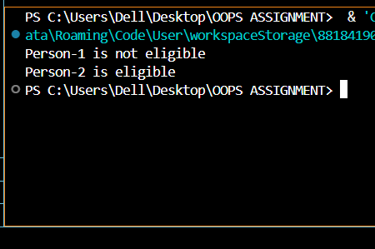
NEGATIVE CASE:
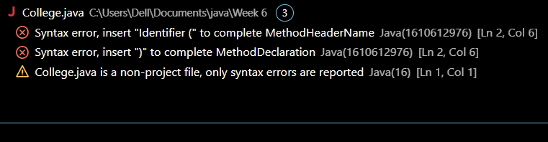

ERROR :
S.No | Error type | Reason for error | Rectification
1 | syntax error | String forgot in main function | String is added
2 | Logical error | Incorrect logic | Correct logic

Class Diagram:
Student
- name: String
- percentage: double
+ Student(String, double)
+ getName(): String
+ getPercentage(): double

AdmissionSystem
+ isEligibleForUG(Student): boolean
+ isEligibleForPG(Student): boolean

AdmissionSystemDemo
+ main(S
3) AIM: Create a Calculator class with overloaded methos to perform addition:
i) Add two integers
ii) Add two doubles
iii) Add three integers
CLASS DIAGRAM:
Calculator1
+ add(int, int)
+ add(double, dbl)
+ add(int,int,int)
Solution
+main(String[])

Program:
class Calcee{

public int add(int a,int b){
return a+b;
}
public double add(double a,double b){
return a+b;
}
public int add(int a,int b,int c){
return a+b+c;
}
}
class poly3{
public static void main(String[] args){
Calcee C1=new Calcee();
System.out.println("Sum of 2 and 5 is: "+C1.add(2,5));
System.out.println("Sum of 3.2 and 6.5 is: "+C1.add(3.2,6.5));
System.out.println("Sum of 2,5 and 3 is: "+C1.add(2,5,3));
}
}
OUTPUT :
POSITIVE CASE:

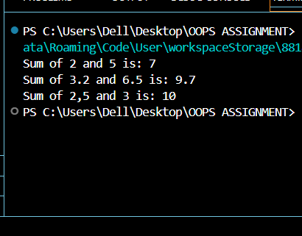

NEGATIVE CASE:

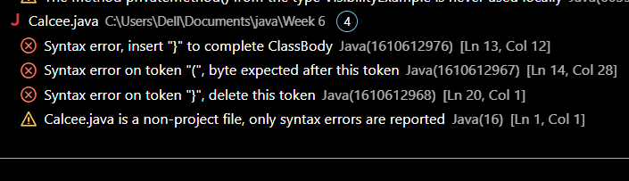

ERROR :
S.No | Error type | Reason for error | Rectification
1 | syntax error | String forgot in main function | String is added
2 | Logical error | Incorrect logic | Correct logic

Class Diagram:
Calculator
+ add(int, int): int
+ add(double, double): double
+ add(int, int, int): int

CalculatorDemo
+ main(String[]): void

4)AIM: Create a shape class with a method calculateArea() that is overloaded for different shapes (e.g square,rectangle). Then create a subclass Circle that overrides the calculteArea().
Class Diagram:
Shape
+calculateArea(double)
+calculateArea(2 doubles)
+calculateArea(2d, String)

Circle
-PI: double |
+calculateArea(double)

ShapeAreaCalculator
+main()

Program:
class Shape {
public double calculateArea(double side) {
return side * side;
}

public double calculateArea(double length, double width) {
return length * width;
}
}

class Circle extends Shape {
public double calculateCircleArea(double radius) {
return Math.PI * radius * radius;
}
}

public class ShapeDemo {
public static void main(String[] args) {
Shape shape = new Shape();
Circle circle = new Circle();

double squareArea = shape.calculateArea(4.0);
System.out.println("Area of square (side = 4.0): " + squareArea);

double rectangleArea = shape.calculateArea(5.0, 3.0);
System.out.println("Area of rectangle (length = 5.0, width = 3.0): " + rectangleArea);

double circleArea = circle.calculateCircleArea(3.0);
System.out.println("Area of circle (radius = 3.0): " + circleArea);

System.out.println("Rahul,24334,cse c");

}
}
Output: 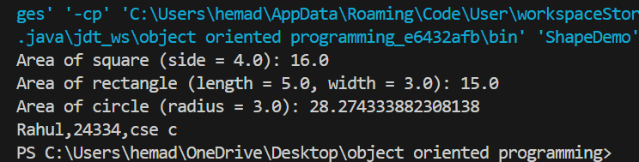

Negative case:
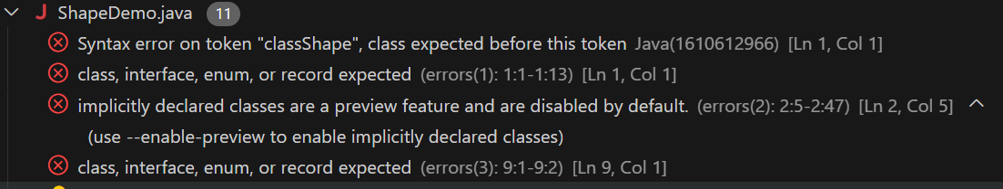

AIM:A college is developing an automated admission system that verifies student’s eligibility for Undergraduate(UG) and Postgraduate(PG) programs. Each program has different eligibility criteria based on the student’s percentage in their previous qualification.
CONDITION:
1.UG admission require minimum of 60%,PG admission require minimum of 70%.

CLASS DIAGRAM:
Student
- name: String
- percentage: double
+ Student(name, percentage)
+ Eligibility(): void

UG
+ UG(name, percentage) + Eligibility(): void
PG
+ PG(name, percentage) + Eligibility(): void

PROGRAM:
class Student {
protected String name;
protected double percentage;

Student(String name, double percentage) {
this.name = name;
this.percentage = percentage;
}

public void Eligibility() {
System.out.println(name + " must meet the general admission criteria");
}
}

class UG extends Student {
UG(String name, double percentage) {
super(name, percentage);
}

@Override
public void Eligibility() {
if (percentage > 59) {
System.out.println(name + " is eligible for UG admission");
} else {
System.out.println(name + " is Not eligible for UG admission");
}
}
}

class PG extends Student {
PG(String name, double percentage) {
super(name, percentage);
}

@Override
public void Eligibility() {
if (percentage > 69) {
System.out.println(name + " is eligible for PG admission");
} else {
System.out.println(name + " is Not eligible for PG admission");
}
}
}

public class Admission {
public static void main(String[] args) {
UG ug = new UG("RAHUL", 70);
PG pg = new PG("KONDA", 59);
ug.Eligibility();
pg.Eligibility();
System.out.println("Rahul,24334,cse c");
}
}

Output:
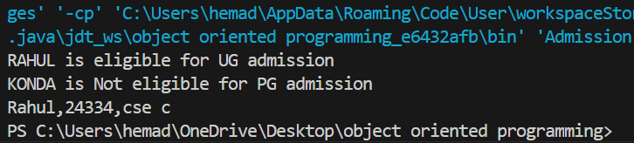
Negative case:
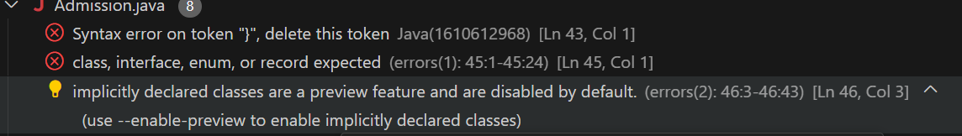
ERROR TABLE:
S.NO | ERROR | RECTIFICATION
1 | java.lang.error | By adding ‘ ; ’

IMPORTANT POINTS:
- Method Overriding: UG and PG override the Eligibility() method from Student.
- Constructor Chaining: super() is used to initialize base class fields
- Protected Access: name and percentage are protected, accessible in child classes.
- Eligibility Logic: Different admission criteria are applied for UG (>59%) and PG (>69%).

